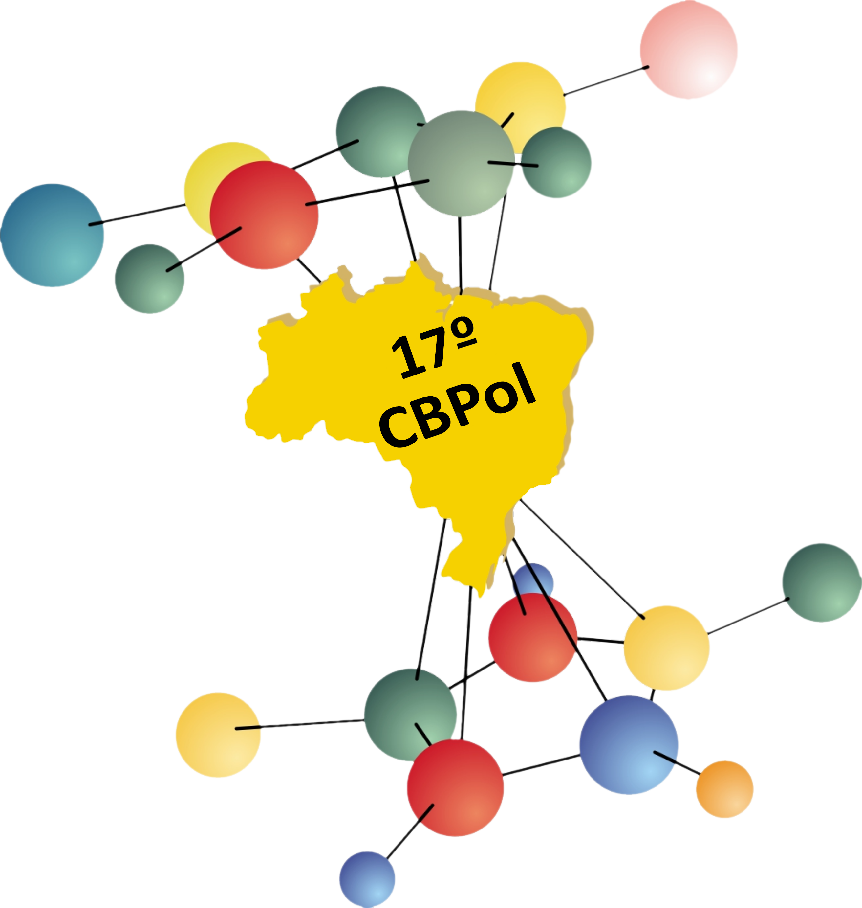

TITLE
CAPITAL LETTERS, TIMES NEW ROMAN 14, BOLD, CENTERED PARAGRAPH, SINGLE SPACE

Write the name of authors following the example below, indicating with *. Example:
Louis T. Shoemaker¹, Rose S. A. Garden² and Bruce Reedwood¹*
(Times New Roman 10, bold, centered paragraph, single space)

Insert here the author(s) affiliation(s). Write the e-mail of the author to whom correspondence should be addressed. Example:
1 – Department of Materials Engineering, University of São Paulo (USP), São Paulo, SP, Brazil corresponding_author@server.com.br
2 – Department of Materials Engineering (DEMa), Federal University of São Carlos (UFSCar), São Carlos, SP, Brazil
(Times New Roman, 10, italic, centered paragraph, single space)

Abstract - The abstract must be no longer than 300 words (single paragraph), 300 Mb, one page. Abbreviations must be defined at their first mention within the abstract. Define well the purpose of the work, the methodology used, and the main results obtained.
(Times New Roman 12, single space, justified paragraph)
If necessary, insert table or figure according to the above instructions. These will be considered in the limiting size of the abstract.

Table (Times New Roman 11, bold) – Insert the table after its title in Times New Roman 11, single space line, justified paragraph, 1 column. If necessary, insert notes below the table in Times New Roman 11, single space line, justified paragraph, 1 column. In the text write Table 1.

Figure (Times New Roman 11, bold) – Write the legend below the Figure, in Times New Roman 11, single space line, justified paragraph, 1 column. In the text write Fig 1.

References (Times New Roman 10, bold) – Follow the examples in Times New Roman 10, single space line, justified paragraph, 1 column.
- For articles: Q. Jiang; T. Horozov; A. Bismarck Polymer 2022, 261, 125406. https://doi.org/10.1016/j.polymer.2022.125406.
- For thesis: F. H. Dutra, Ph.D. Thesis, University of Southampton, 1995.
- For books without editor: E. Haslam, Shikimic Acid Metabolism, John Wiley & Sons, New York, 1993.
- For books with editor: J. G. Buchanan; H. Z. Sable in Selective Organic Transformations, B. S. Thyagarajan, Ed.; Wiley-Interscience, New York, 1972; Vol. 2, 1-95.
- For patents: F. R. Lyle, U.S. Patent 5 973 257, 1985; Chem. Abstr. 1985, 65, 2870.
- For proceedings: O. Barbosa in Proceedings of 10th Brazilian Catalysis Conference, Salvador, 1999, Vol. 1, 343.

Fundings: This field is optional. Indicate fundings if there is any.

Keywords: Insert here up to 5 keywords. Maximum of 40 characters for each keyword.
(Times New Roman 10, italic)
Maximum size of the file: 4 MB. Do not exceed 1 page.

